April 2025

To Whom It May Concern

RE: Laser outsert

There are three-sales part numbers for the Avon green laser outsert, 72601/29, 607056 and 606762.

The exact performance requirements of the laser outsert 72601/29 are classified and are not able to be provided in this letter. However, I can confirm that when evaluated against the specific wavelengths detailed within the 72601/29 specification, the 607056 and 606762 part numbers yield optical densities that meet the performance requirements at those wavelengths.
If you have specific wavelengths of interest to you, we would be happy to provide details on the protection performance of part numbers 607056 and 606762.
I hope that the enclosed information is useful to you.

Yours sincerely,
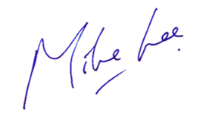

Mike Lee
Senior Product Manager - APR, Avon Protection

